LAB EXPERIMENT RECORD

SET 16: CUSTOMER DEMOGRAPHICS ANALYSIS

Department | AIML
Course Code / Course Name | DSA0602 / Data Handling and Visualization
Experiment | Data Visualization using Tableau
Name | S.Naveen Kumar
Register Number | 192425176
Date | 10 October 2026
Day | Thursday

SET 16: CUSTOMER DEMOGRAPHICS ANALYSIS
Aim
To analyze customer demographic information using R programming by creating a bar chart, pie chart, table, and interactive dashboard.

Dataset
The dataset contains Customer ID, Age, Gender, and Income.
R Code – Create Dataset customer <- data.frame( Customer_ID = c(1, 2, 3),
Age = c(28, 35, 42),
Gender = c("Female", "Male", "Female"), Income = c(50000, 60000, 75000)
)

customer

Question 1: Create a Bar Chart to Visualize Customer Ages R Code
library(ggplot2)

ggplot(customer, aes(x = factor(Customer_ID), y = Age)) + geom_bar(stat = "identity") +
labs(
title = "Distribution of Customer Ages", x = "Customer ID",
y = "Age"
)

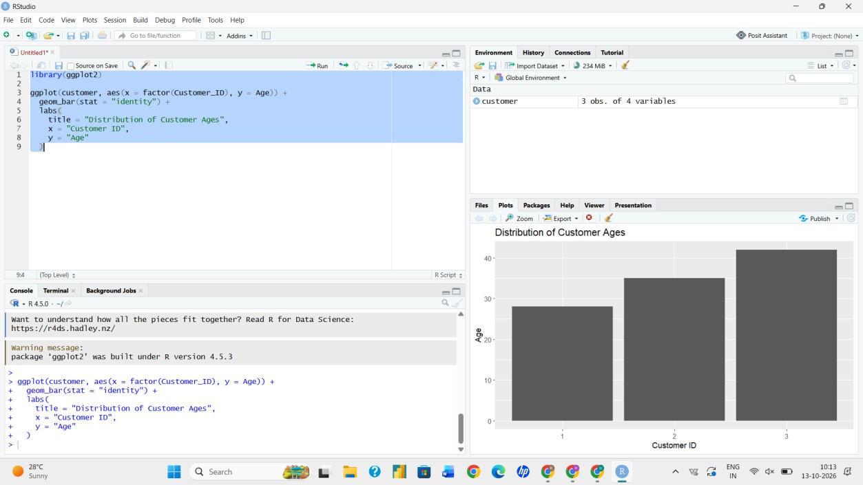

Result
The bar chart displays the age of each customer. Customer 1 is 28 years old, Customer 2 is 35 years old, and Customer 3 is 42 years old.

Question 2: Generate a Pie Chart for Gender Distribution R Code
gender_count <- table(customer$Gender)

pie(
gender_count,
main = "Distribution of Customers by Gender", labels = paste(names(gender_count), gender_count)
)

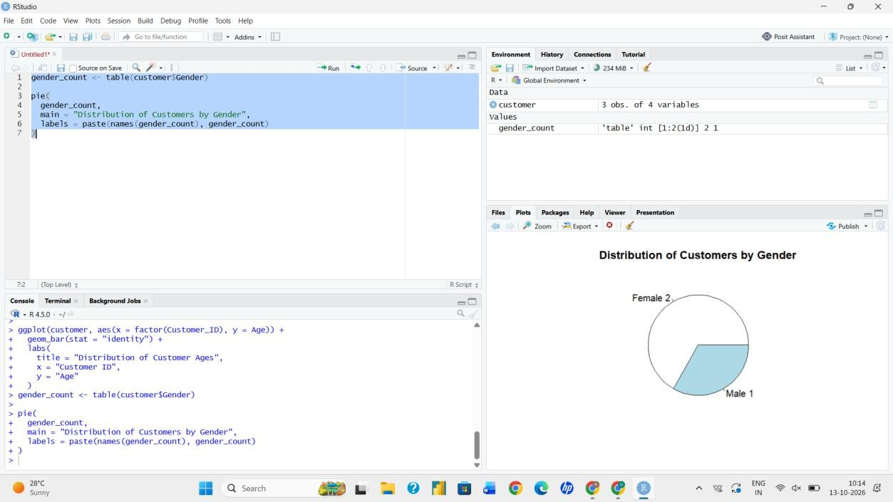

Result
The pie chart shows that there are 2 female customers and 1 male customer.

Question 3: Build a Table Showing Demographic Information R Code
Customer

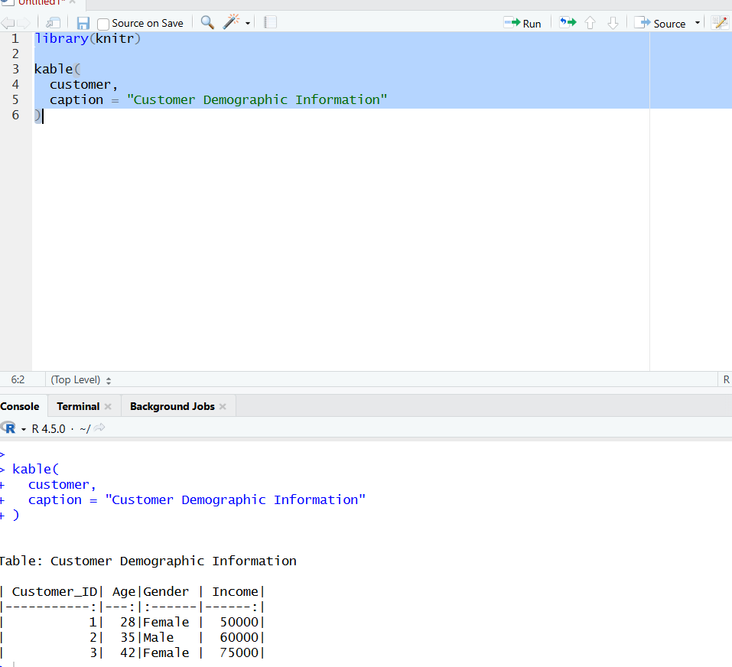

Result
The table displays Customer ID, Age, Gender, and Income for each customer.

Question 4: Create an Interactive Dashboard R Code
library(shiny) library(ggplot2) library(plotly) library(DT)

ui <- fluidPage(

titlePanel("Customer Demographics Dashboard"),

plotlyOutput("agePlot"), plotlyOutput("genderPlot"), DTOutput("customerTable")
)

server <- function(input, output) {

output$agePlot <- renderPlotly({
p <- ggplot(customer, aes(x = factor(Customer_ID), y = Age)) + geom_bar(stat = "identity") +
labs(
title = "Customer Ages", x = "Customer ID",
y = "Age"
)

ggplotly(p)
})

output$genderPlot <- renderPlotly({
p <- ggplot(customer, aes(x = "", fill = Gender)) + geom_bar(width = 1) +
coord_polar("y") +
labs(title = "Gender Distribution")

ggplotly(p)
})

output$customerTable <- renderDT({ customer
})
}

shinyApp(ui, server)
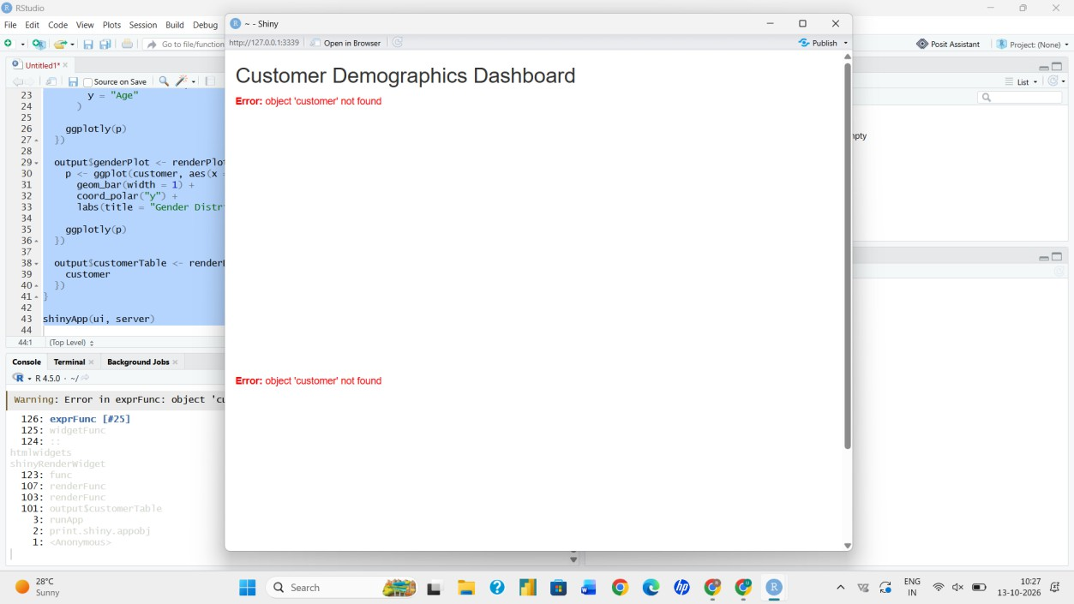

Result
An interactive dashboard is created containing the customer age chart, gender pie chart, and demographic table.

Conclusion
Customer demographic data was successfully analyzed using R. Charts, tables, and an interactive dashboard were created to understand the customer information.

